CaseManagement_CreationOfCase_Instance23_06-Aug-2018_04-07-22_AM_MouseClickActionMoveToElementBycssSelectorspanTabSFA.png

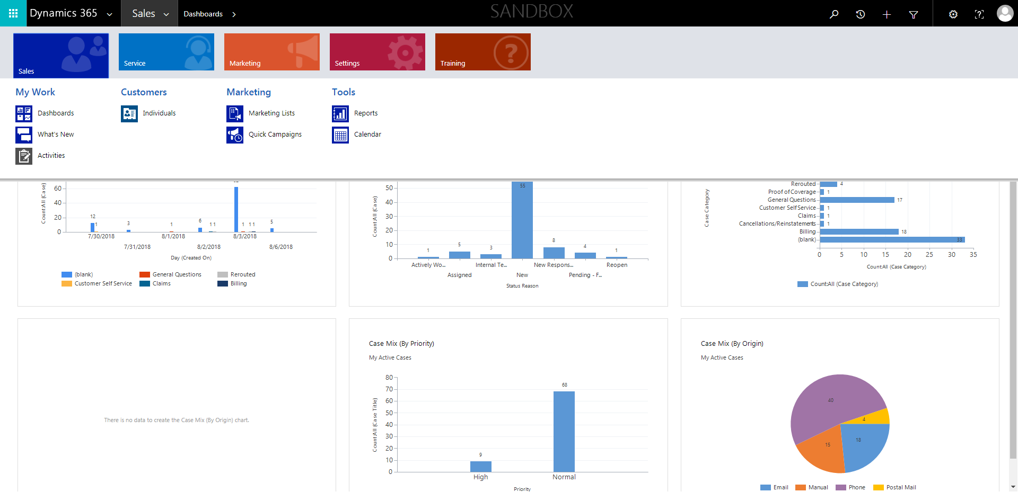

CaseManagement_CreationOfCase_Instance23_06-Aug-2018_04-06-44_AM_MouseClickActiononStaleElement.png

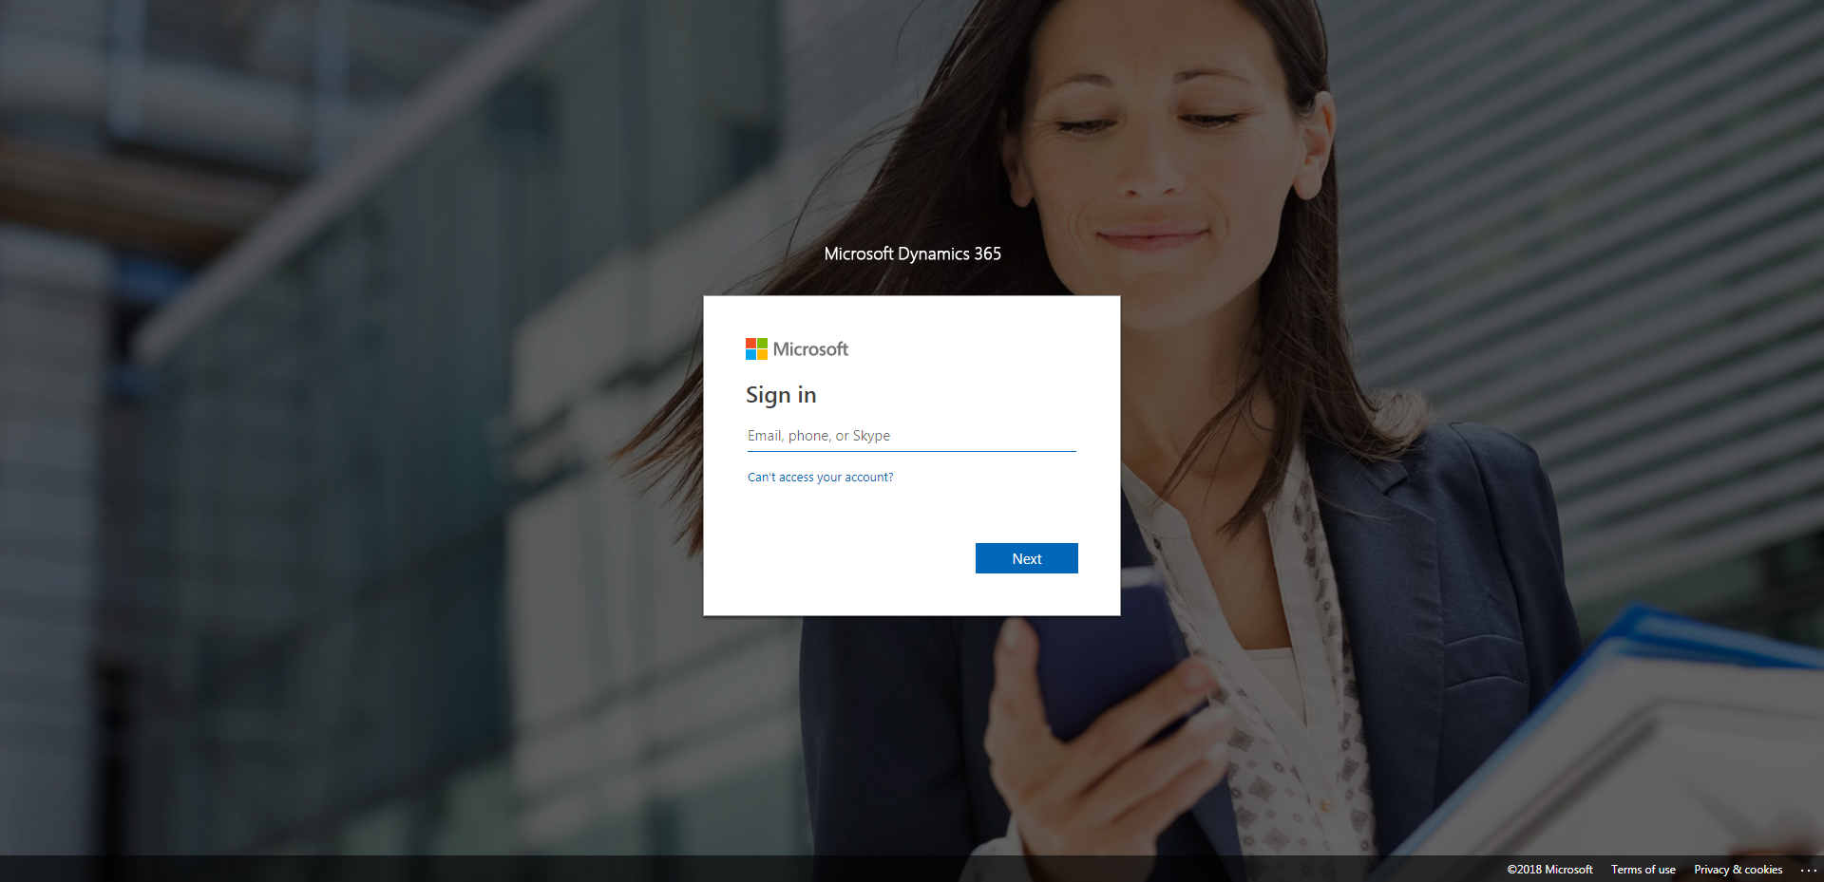

CaseManagement_CreationOfCase_Instance23_06-Aug-2018_04-07-11_AM_SingleSignOn.png

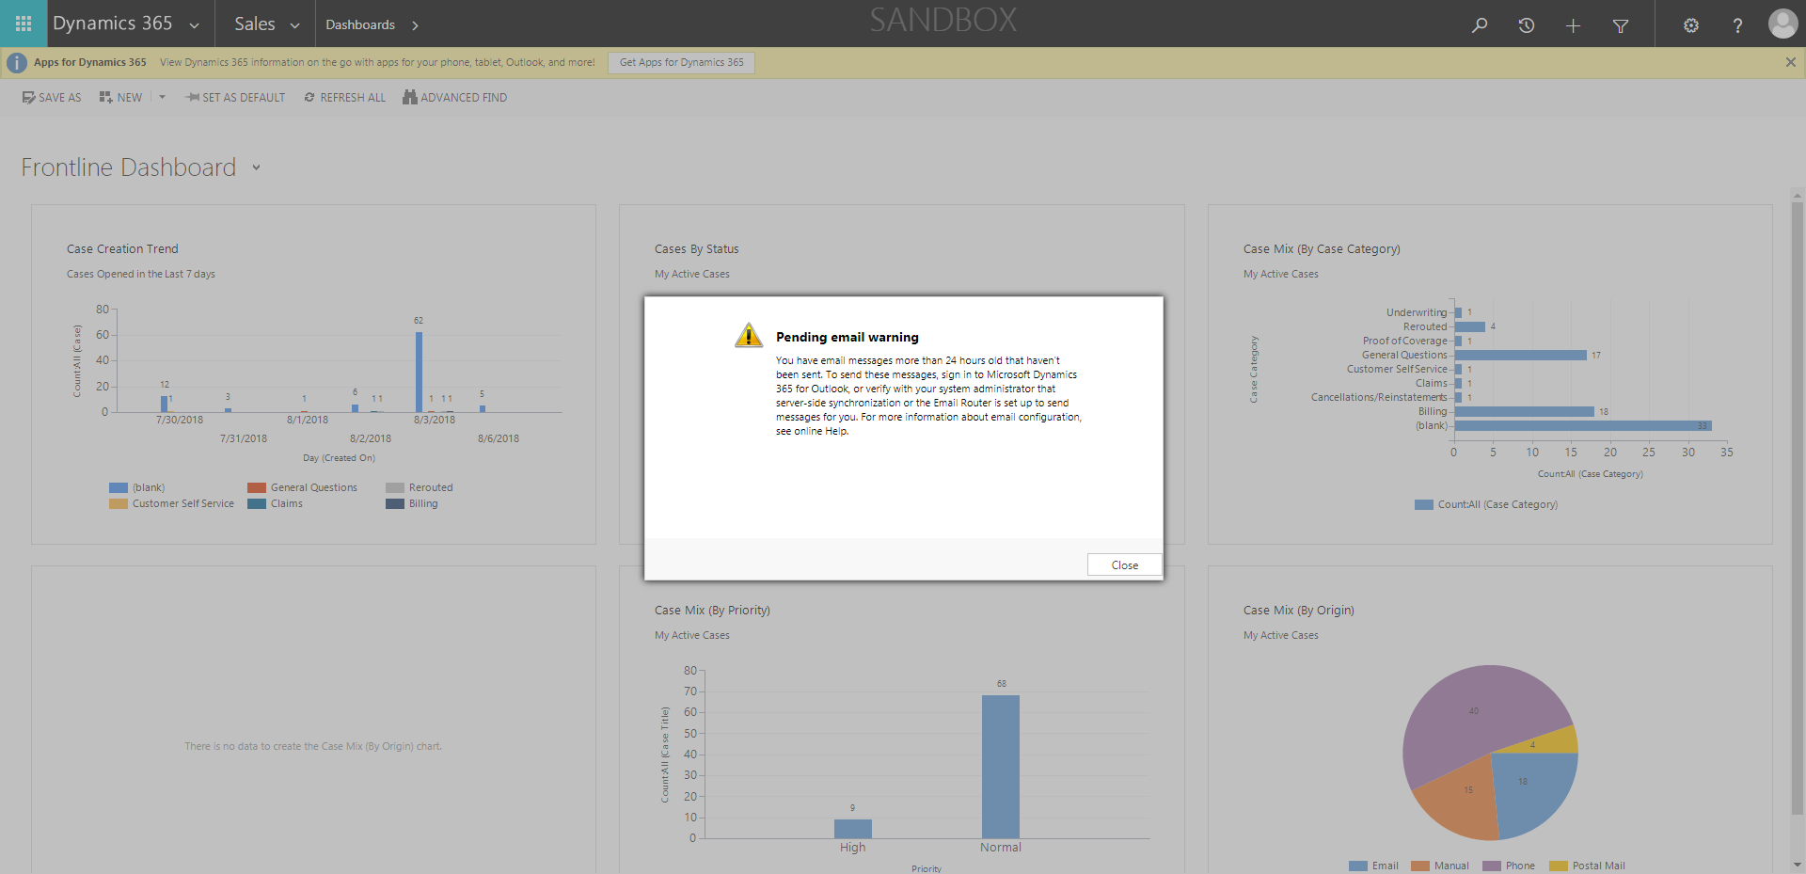

CaseManagement_CreationOfCase_Instance23_06-Aug-2018_04-07-23_AM_MouseClickActionMoveToElementByxpathimgaltServiceparentspan.png

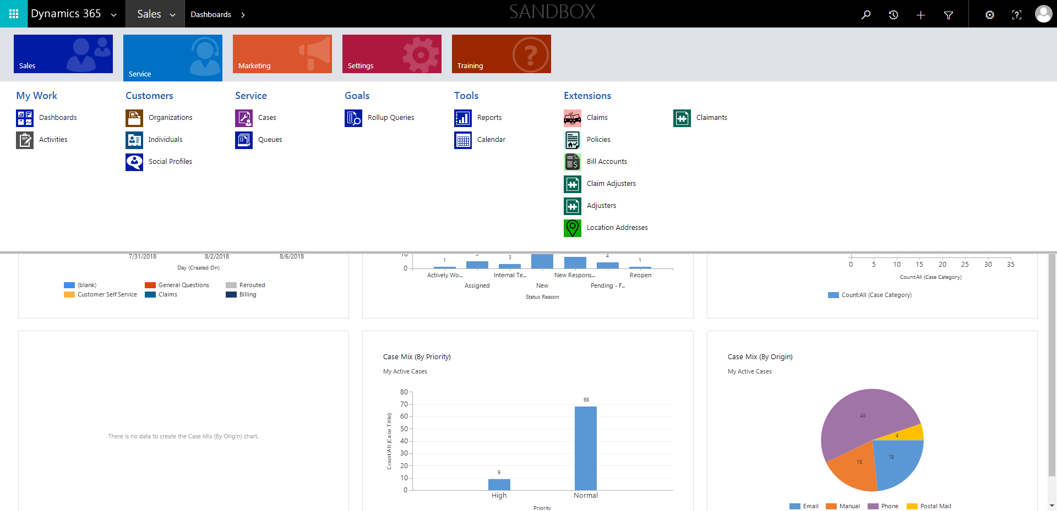

CaseManagement_CreationOfCase_Instance23_06-Aug-2018_04-07-40_AM_MouseClickActionMoveToElementBycssSelectorspanTabCS.png

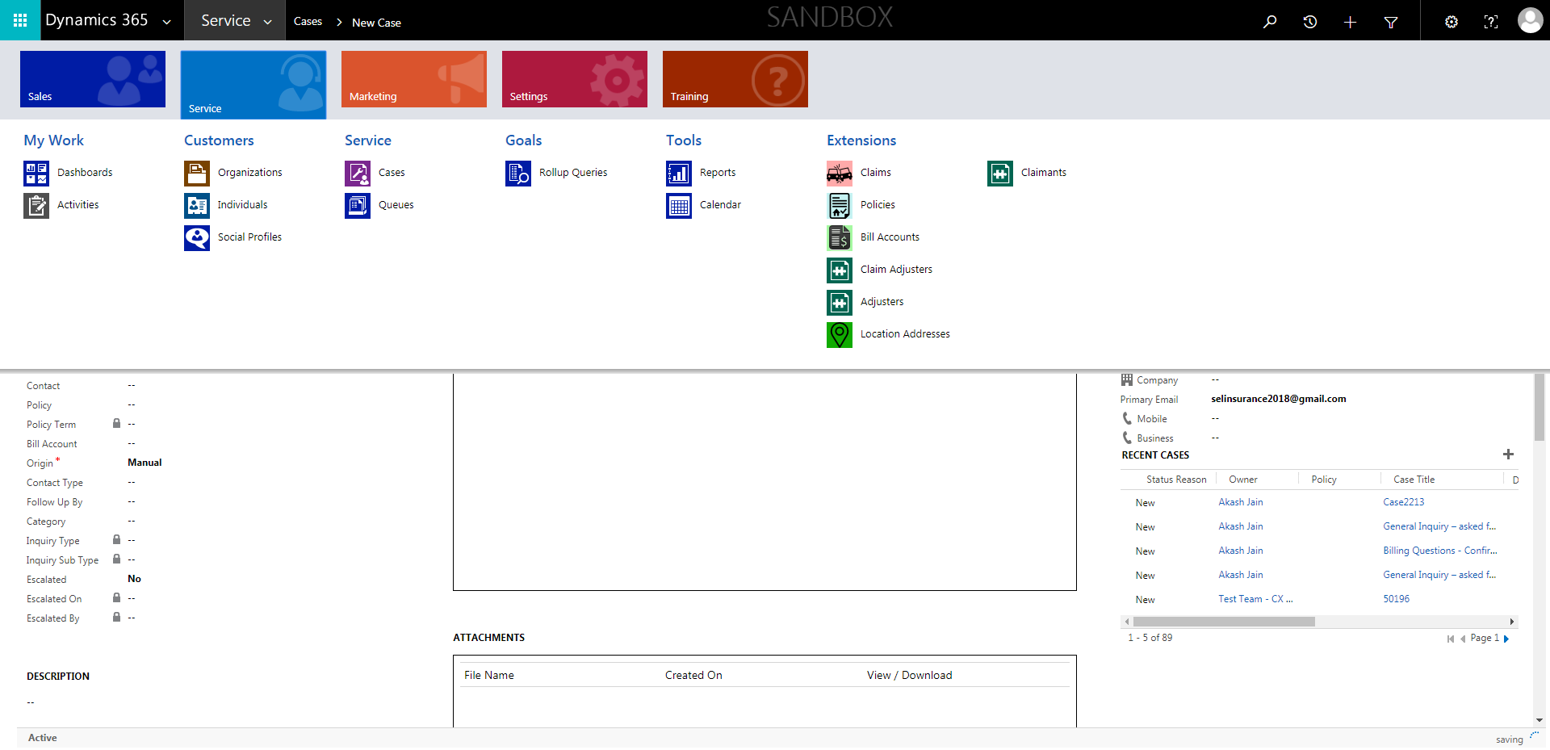

CaseManagement_CreationOfCase_Instance23_06-Aug-2018_04-06-46_AM_EnterTextAction.png

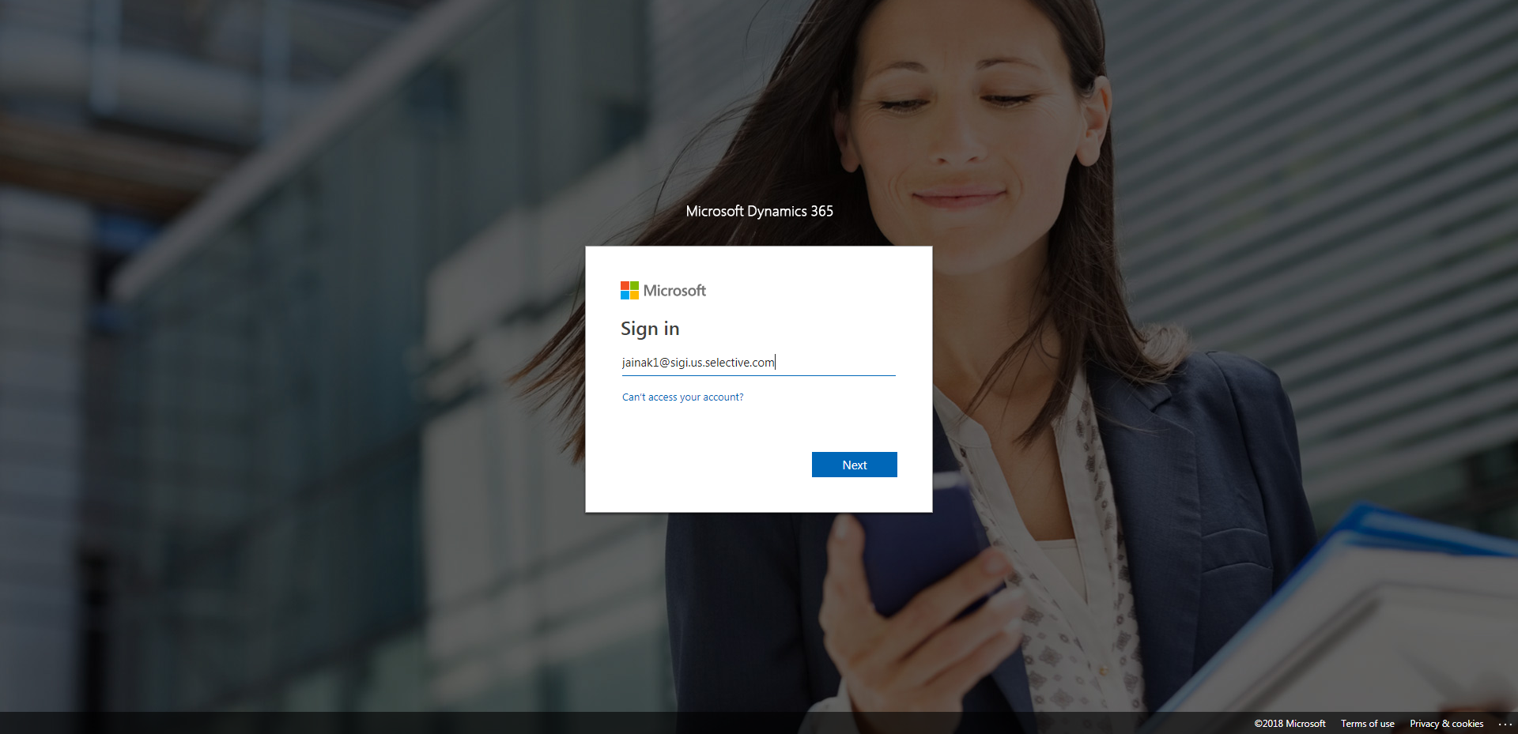

CaseManagement_CreationOfCase_Instance23_06-Aug-2018_04-07-18_AM_SingleSignOn.png

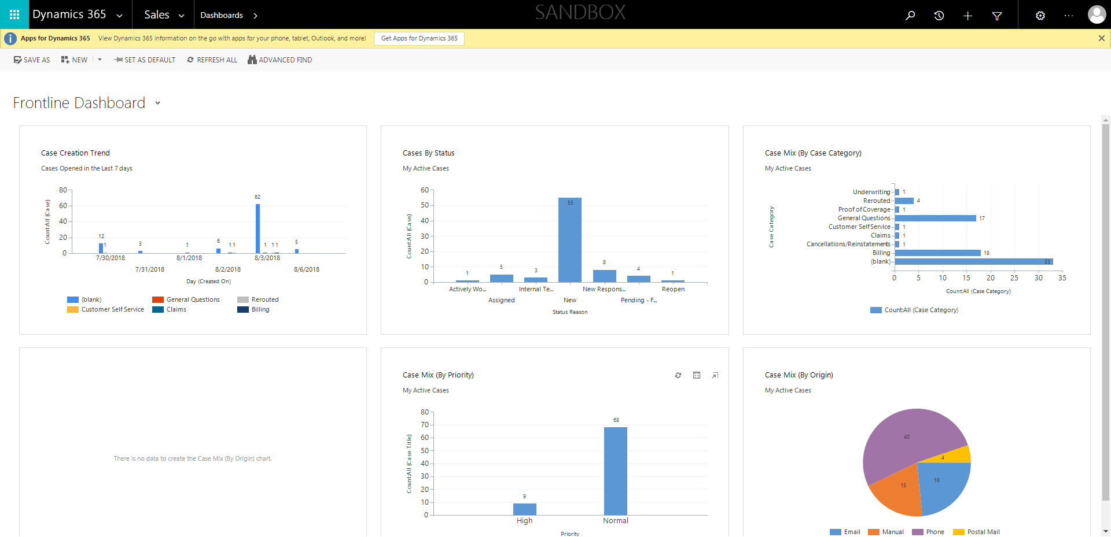

CaseManagement_CreationOfCase_Instance23_06-Aug-2018_04-07-46_AM_ValidatingCaseentitynavigation.png

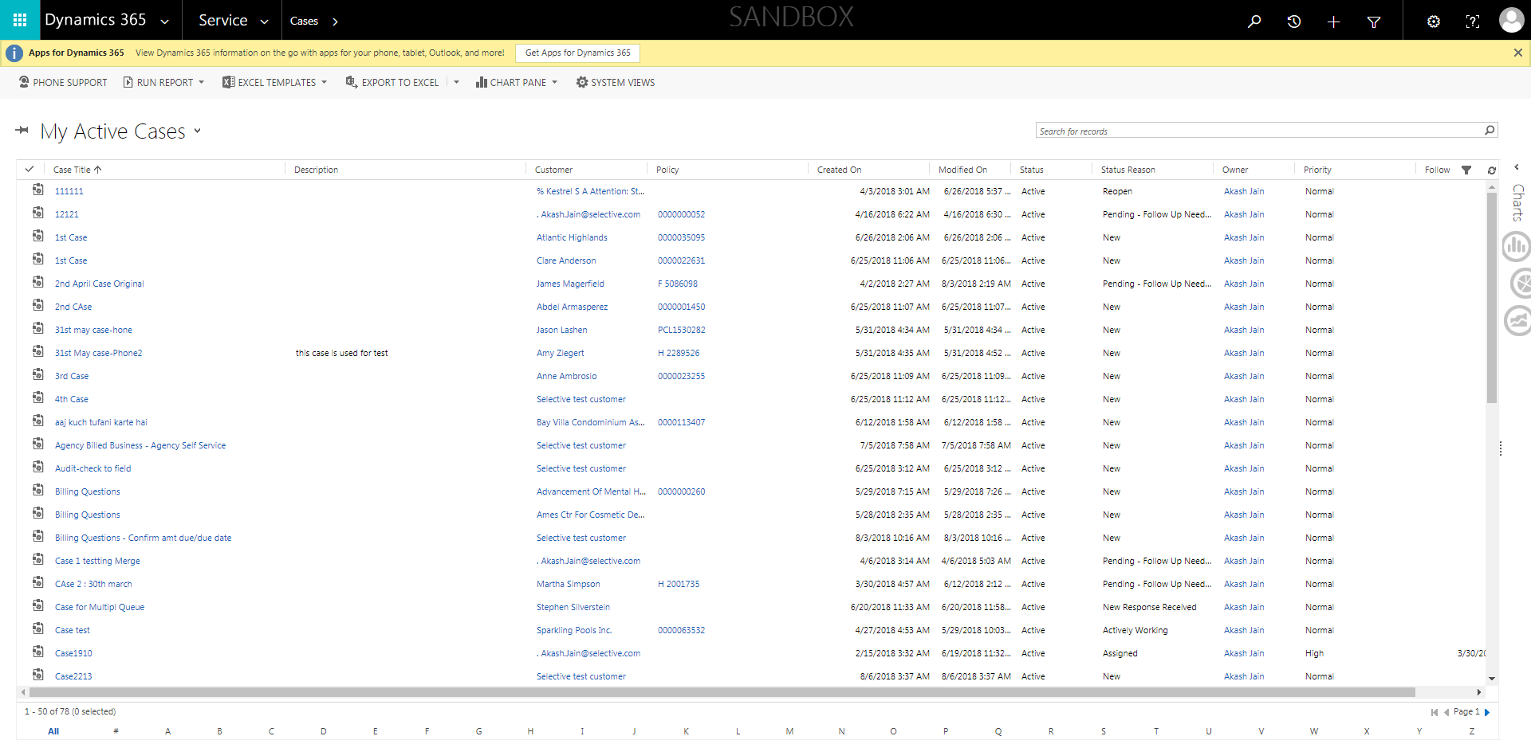

CaseManagement_CreationOfCase_Instance23_06-Aug-2018_04-07-48_AM_ValidatingCaseentitynavigation.png

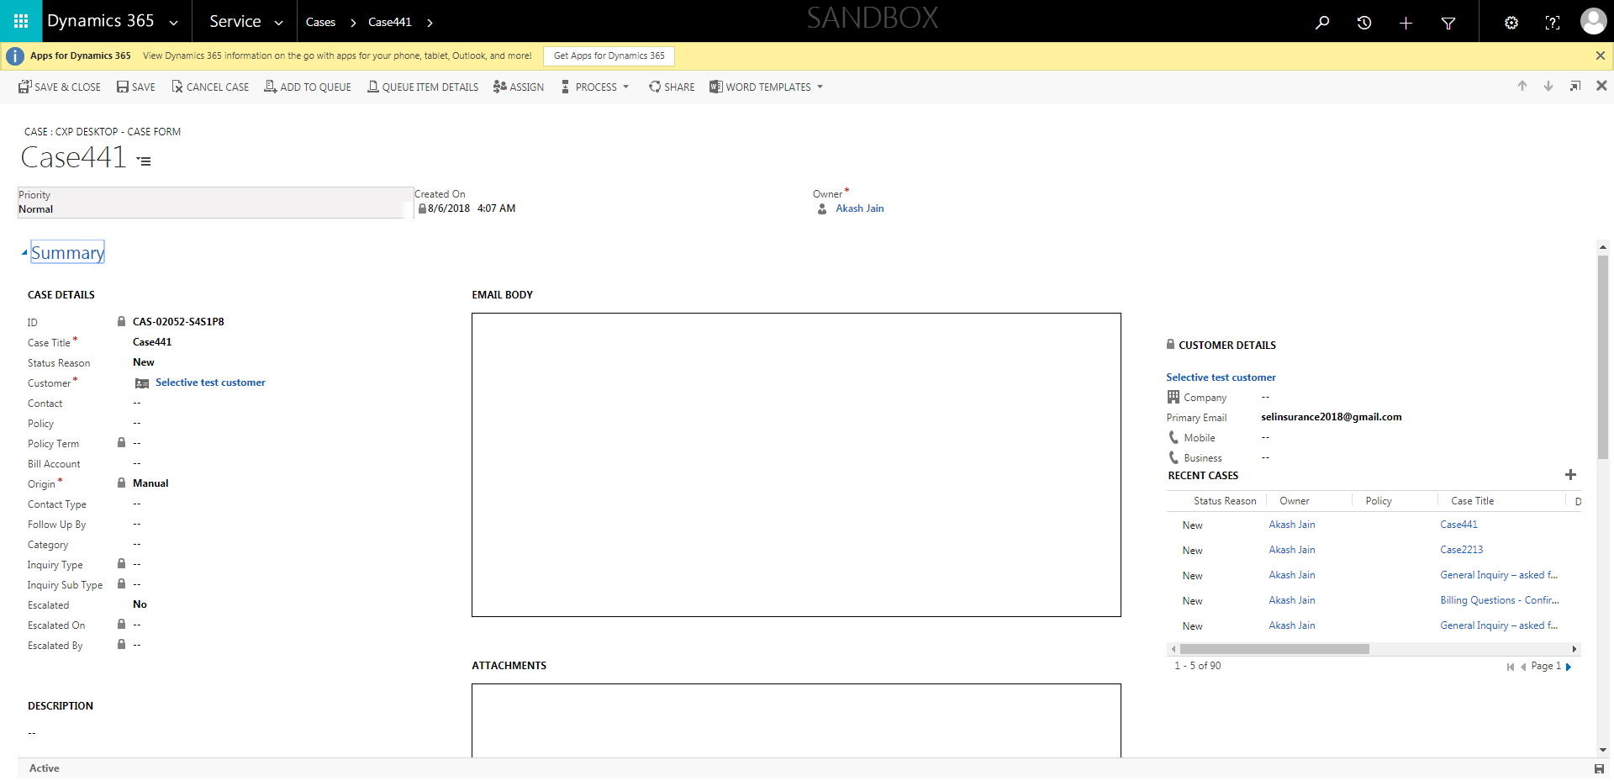

CaseManagement_CreationOfCase_Instance23_06-Aug-2018_04-07-45_AM_MouseClickActionMoveToElementBycssSelectoranavcases.png



CaseManagement_CreationOfCase_Instance23_06-Aug-2018_04-06-47_AM_MouseClickActiononStaleElement.png

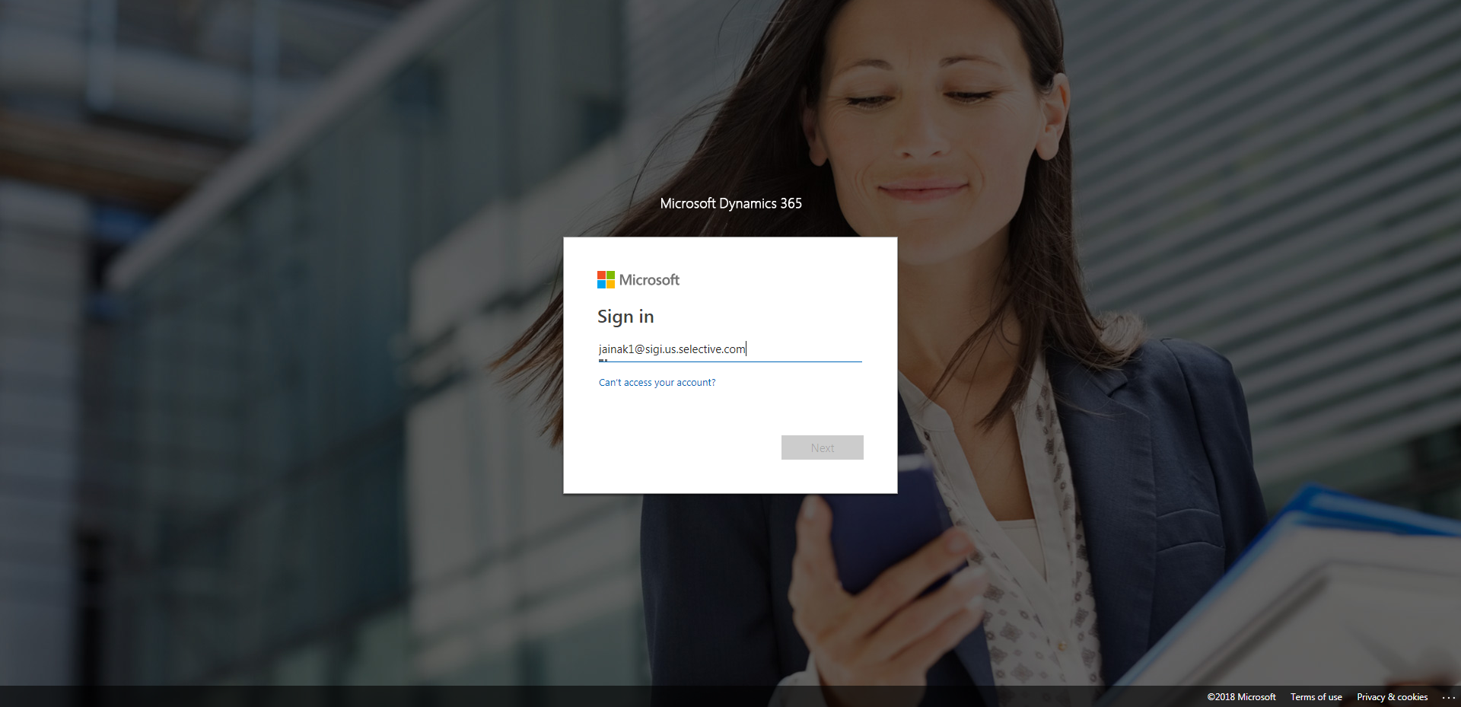

CaseManagement_CreationOfCase_Instance23_06-Aug-2018_04-07-42_AM_MouseClickActionMoveToElementByxpathimgaltServiceparentspan.png

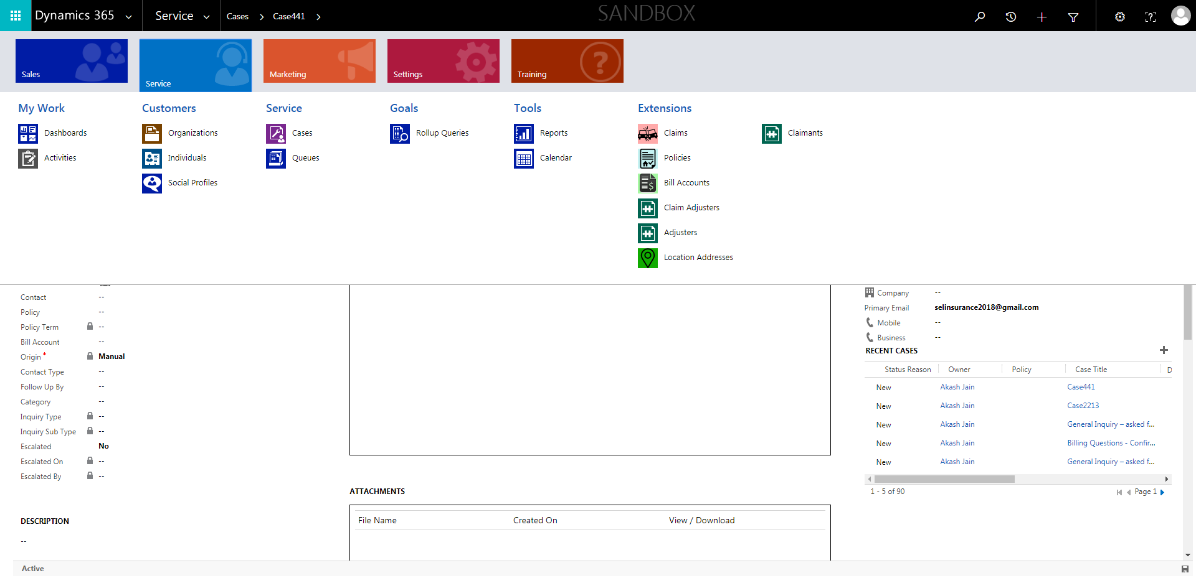

CaseManagement_CreationOfCase_Instance23_06-Aug-2018_04-07-24_AM_MouseClickActionMoveToElementBycssSelectoranavcases.png

